**A Project Report on**

Banasthali Liberalization Incentive Scheme

For Staff

Submitted for the partial fulfillment of the award of

### B.TECH (IT) III YEAR

By

Amandeep Kaur

(9021)

Anshulika Rathore

(9026)

Priyata Sinha

(9082)

Rashika Rastogi

(9084)

To

Department of Computer Science, AIM&ACT

Under the supervision of

Mrs. Chandani Joshi (Internal)



Banasthali Vidyapith

(2016-17)

**AIM & ACT DEPARTMENT**

***CERTIFICATE***

### Certified that the students Amandeep Kaur, Anshulika Rathore, Priyata Sinha and Rashika Rastogi have carried out the project work titled “Banasthali Libralization Incentive Scheme For Staff” from _____(date) to ______ (date) for the award of the B.Tech(IT) III Year from Banasthali Vidyapith under my supervision. The thesis embodies result of original work and studies carried out by Students themselves and the contents of the thesis do not form the basis for the award of any other degree to the candidate or to anybody else.

Chandani Joshi

Assistant Professor

Place: Banasthali Vidyapith

Date:

**(Banasthali University Letter Head)**

### *CERTIFICATE*

### This is to certify that Ms. Amandeep Kaur Roll No. 9021 a student of B.Tech(IT)IIIyear, VISemester of Banasthali Vidyapith has completed the industrial project titled “Banasthali Liberalization Incentive Scheme For Staff” in Banasthali Vidyapith of six months duration in partial fulfillment of B.Tech.

**Internal Guide**

Mrs. Chandani Joshi

**(Banasthali University Letter Head)**

### *CERTIFICATE*

### This is to certify that Ms. Anshulika Rathore Roll No. 9026 a student of B.Tech(IT)IIIyear, VISemester of Banasthali Vidyapith has completed the industrial project titled “Banasthali Liberalization Incentive Scheme For Staff” in Banasthali Vidyapith of six months duration in partial fulfillment of B.Tech.

**Internal Guide**

Mrs. Chandani Joshi

**(Banasthali University Letter Head)**

### *CERTIFICATE*

### This is to certify that Ms. Priyata Sinha Roll No. 9082 a student of B.Tech(IT)IIIyear, VISemester of Banasthali Vidyapith has completed the industrial project titled “Banasthali Liberalization Incentive Scheme For Staff” in Banasthali Vidyapith of six months duration in partial fulfillment of B.Tech.

**Internal Guide**

Mrs. Chandani Joshi

**(Banasthali University Letter Head)**

### *CERTIFICATE*

### This is to certify that Ms. Rashika Rastogi Roll No. 9084 a student of B.Tech(IT)IIIyear, VISemester of Banasthali Vidyapith has completed the industrial project titled “Banasthali Liberalization Incentive Scheme For Staff” in Banasthali Vidyapith of six months duration in partial fulfillment of B.Tech.

**Internal Guide**

Mrs. Chandani Joshi

***ACKNOWLEDGEMENT***

The successful completion of this project is attributed to great help received from people. We express our sincere gratitude to Professor G.N. PUROHIT (Dean of Department of Computer Science And Electronics, AIM & ACT at Banasthali University) for giving us this opportunity to work in this prestigious organization and encouraging us during our project period.

We express our gratitude to our supervisor Mrs. CHANDANI JOSHI for her valuable guidance and encouragement during each step of this project.

We would also like to give our thanks to all our “Technical Staff” for their valuable time and effort.

Last but not the least we would like to thank all friend for giving useful suggestions and ideas for improving our project.

**Your Sincerely,** Amandeep Kaur (9021) Anshulika Rathore (9026) Priyata Sinha (9082)

Rashika Rastogi (9084)

***ABSTRACT***

The main purpose of this project is to develop such a system that is **BLISS (Banasthali Liberalization Incentive Scheme for Staff)** ,which will automate the manual employee appraisal form. It is designed for Banasthali University **(Aim & Act Department)** employees.

BLISS is a web-based service which intends to provide the facility to faculties to submit their appraisal form online. The manual work may leads to inaccurate information, biased information, it require a lot of time and it also needs to memorize things.

Scope of this system is within an organization, i.e. it will be used through Intranet. This system is based on **3-tier architecture.**

There are basically eight actors in this project. They are – Faculty, Head of department (HOD), Dean, Admin, Time-table Coordinator, Leave Coordinator, Examination Coordinator and Office Coordinator.

Each actor will have to enter their login id and password to enter in the system and perform their tasks according to appraisal form.

***CONTENTS***

* Objective
* SRS

1. Introduction

2. Product Functions

3. H/W & S/W Requirements

3. Specific Requirements

4. Use-Case Diagram

* SDS

2.1 Activity Diagram

2.2 Sequence Diagram

2.3 Class Diagram

2.4 E-R Diagram

3. Data Design

3.1 Structure & Relationship

4. User Interface Diagram

4.1 Screenshots

5. Conclusion

* Testing
* Appendices
* References

***OBJECTIVE***

The objective of this document is to describe the software requirement in developing the system **BLISS (Banasthali Liberalization Incentive Scheme for Staff)** which will automate the manual employee appraisal form.

This system is designed for Banasthali University employees in order to reduce paper work and for their convenience.

It also eases the form filling work of employees.

**SOFTWARE**

**REQUIREMENT**

**SPECIFICATION**

**1. INTRODUCTION:**

**1.1Purpose**

The purpose of this document is to describe the software requirement in developing the system **BLISS (Banasthali Liberalization Incentive Scheme for Staff)** which will automate the manual employee appraisal form.

This system is designed for Banasthali University employees in order to reduce paper work and for their convenience.

It also ease the form filling work of employees.

**1.2Scope**

BLISS is a web-based service which intends to provide facility to Banasthali Vidyapith faculties to submit their appraisal form online.

Initially, it will be developed for Banasthali Vidyapith only for AIM & ACT (CS/IT) department and later it will be implemented for all the other departments as well as organizations too.

The scope of this project can be listed as under:

* Scope of BLISS system is within an organization, i.e.it will be used through Intranet.
* This system is based on 3-tier architecture.
* Five types of users will be using this system. User can be **Vice Chancellor, Dean, Head of Department (HOD), Faculty(AIM & ACT), Admin and** various **Coordinators.**

**1.3 Definitions, Acronyms and Abbreviations**

**Title:** BLISS system

* **BLISS:** Banasthali Liberalization Incentive Scheme for Staff.
* **HTML:** Hypertext Markup Language is a markup language used to design static web pages.
* **HTTP:** Hypertext Transfer Protocol is a transaction oriented client/server protocol between web browser and web server.
* **HTTPS:** Secure Hypertext Transfer Protocol is a HTTP over SSL (Secure Socket Layer).
* **WWW:** World Wide Web.
* **TCP/IP:** Transmission Control Protocol/Internet Protocol, the suite of communication protocols used to connect hosts on the internet.TCP/IP uses several protocols, the two main ones being TCP and IP.
* **DB:** Database.
* **JDBC:** Java Database Connectivity API.
* **API:** Application Program Interface.
* **RAM:** Random Access Memory.
* **HDD:** Hard Disk Drive.
* **IEEE:** Institute of Electrical and Electronics Engineers.
* **OS:** Operating System.

**1.4 Overview**

An Incentive is something that motivates an individual to perform an action.

Every organization has some tasks and for those tasks, the organization always try to find the way to make their employees achieved their targets in proper time duration and if not, what are the measures that are to be taken to improve their performance.

The employee performance evaluation process is done manually in Banasthali University which may leads to inaccurate information, biased information , it require a lot of time and it also needs to memorize things.

In our proposed system, it facilitate the employees to fill the form online in which they don’t need to memorize things, they can easily fetch information from databases and also attach required documents.

**2. GENERAL DESCRIPTION:**

**2.1Product Perspective**

This system is mainly aimed towards teaching faculty members of Banasthali Vidyapith and Administrator.

This system will be user friendly, covenant and reliable.

HTML

Client HTTP/HTTPS

(Customer)

JDBC My SQL

Java Server

Client

Software TCP/IP

(System User)

**Client Side Application Database**

**Server Server**

**2.2 Product Functions**

* There are various users who can login to the system. They are faculty member, as higher authority such as VC, Dean, HOD, Admin, and Coordinator.
* System automatically fetches some information from the database, to be verified and demand for the remaining fields to be filled.
* Save and store the attachments provided by user if required.
* Save the data if user wants to leave the page.
* Higher authority, provide credit points on the basis of the submitted form and can also edit it.
* Sign out from the system.

**2.3 User Characteristics**

The user must have the ability to use the system.

* **FACULTY**

These kinds of users are the teachers of AIM & ACT (CS&IT) department of Banasthali, who will fill the form. They won’t have any right regarding to edit the fetched information.

* **HEAD OF DEPARTMENT**

HOD i.e. the head of the department ,have the rights to view, edit the credit points and also the information if required.

* **DEAN**

Dean i.e. the higher authority has the right to view, edit the credit points and also edit the information if required.

* **ADMIN**

Admin i.e. the higher authority has the rights to provide incentive to employees of (AIM & ACT ) department according to their performance.

* **COORDINATORS**

These types of users are basically the coordinator of whole system. They maintain the database like Time Table Management, Examination Duties , Workshops , Events Duties and Leave Management etc.

* **VICE CHANCELLOR**

Final incentive will be provided by the VC’s approval.

**2.4 General Constraints**

* ***Higher Order Language Functions :***

The JSP will be used for developing the web pages with the help of Net beans editor and for the database information, My SQL server will be used.

* ***Safety and Security Consideration :***

Password and the valid username are the security issue.

* Unauthorized users will not be able to use the software.
* Any substantial enhancement in system will require approval of the administrator.
* Higher authority cannot be biased for a particular employee regarding the credit points.

**2.5 Technology Used**

* **Front End**: JSP with java.
* **Back End**: My SQL Server.
* **Design Tool**: Net Beans
* **Web Server**: JDBC Java

**2.6 Hardware Interface**

**Server side**

* **RAM**: 2 GB
* **HDD**: 1 GB of free disk space.
* **Processor**: 2.6 GHz Intel (P4) or onwards.

**Client side**

* **RAM**: 512 MB
* **HDD**: 750 MB of free disk space.
* **Processor**: 800 MHz Intel (P3) or onwards.

**2.7 Software Interface**

**Server side**

* **RAM**: 2 GB
* **HDD**: 1 GB of free disk space.
* **Processor**: 2.6 GHz Intel (P4)

**Client side**

* **RAM**: 512 MB
* **HDD**: 750 MB of free disk space.
* **Processor**: 800 MHz Intel (P3) or onwards

**3. SPECIFIC REQUIREMENTS**

**3.1 Functional Requirements**

We describe the functional requirements by giving various use cases:

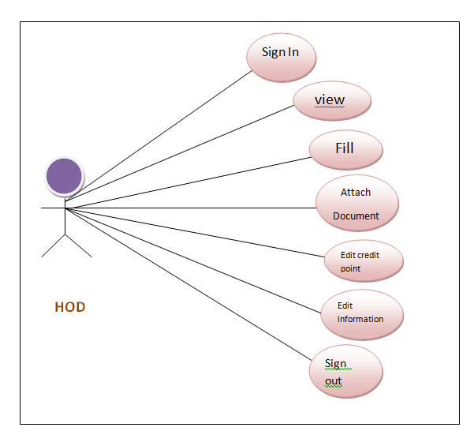

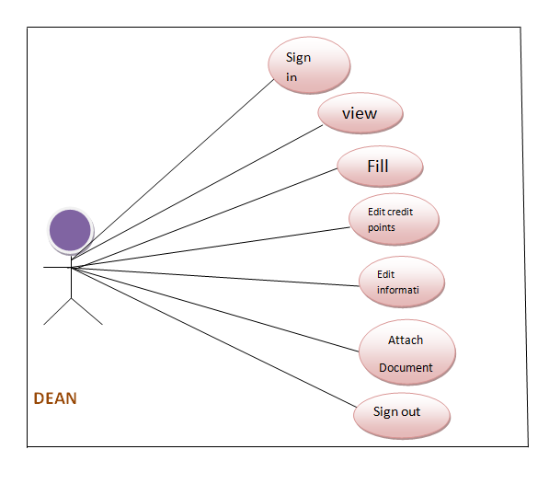

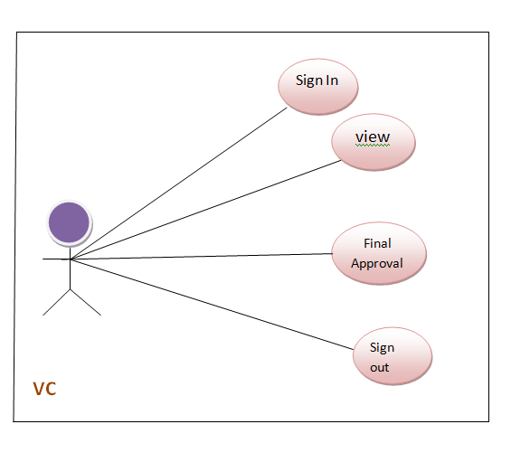

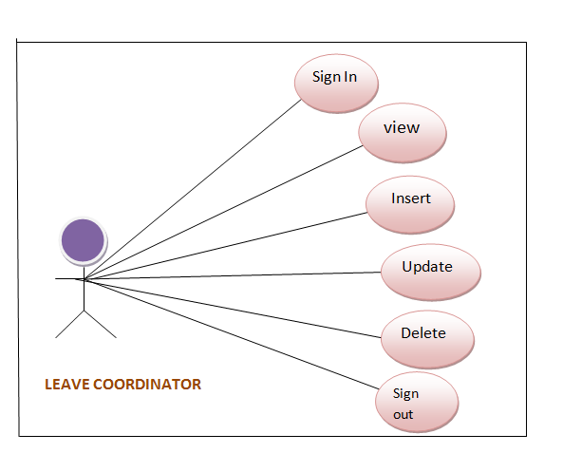

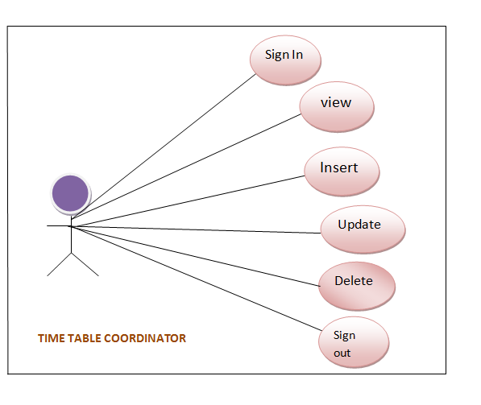

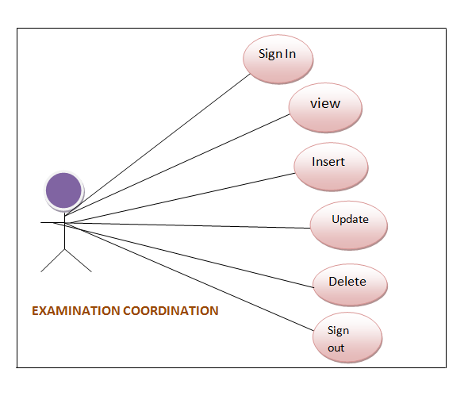

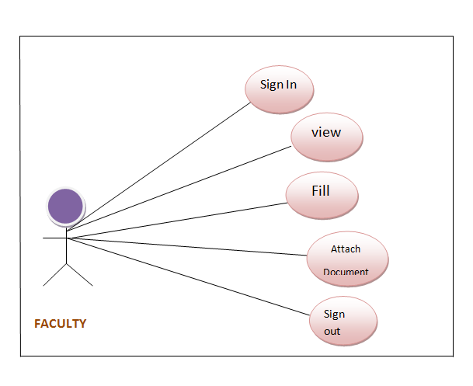

**Sign-In**

|  |  |
| --- | --- |
| Use Case No.. | 1 |
| Use Case Name. | Sign-In |
| 0Actors: | Teachers , HOD , Dean , Coordinators ,VC, |
| Description | This module helps the Teacher, HOD, Dean, Coordinators and VC to Sign in. |
| Pre-Condition | The user must know Login id & password to enter in the system. |
| Normal Course Events | 1. User enters their Login_Id.  2. User enters their password.  3. Click Login button.  4. Reset  5.Error message will be generated if any wrong login Id or password.  5. System connects to database.  6. Appraisal form displayed. |
| Output | User homepage will be displayed. |

**Table 1: Use case of Sign-In**

**Sign-Out**

|  |  |
| --- | --- |
| Use Case No. | 2 |
| Use Case Name. | Sign-Out |
| Actors: | Teachers, HOD, Dean, Coordinators and VC |
| Description | This module helps the Teacher, HOD, Dean, Coordinators and VC to Sign out. |
| Pre-Condition | The user must be signed-in to the system. |
| Normal Course Events | 1. Click Sign-out button.  2. Database connection terminated.  3. User sign-out successfully.  4. User will be directed to homepage. |
| Alternative Courses | In case, user accidently closed the tab, then error message will be generated. |
| Output | User homepage will be displayed. |

**Table 2: Use case of Sign-out**

**Updation**

|  |  |
| --- | --- |
| Use Case No. | 3 |
| Use Case Name. | Updation |
| Actors: | HOD , Dean ,Coordinators and VC |
| Description | This module helps the HOD, Dean, Coordinators and VC to update the information. |
| Pre-Condition | The user must be signed-in the system. |
| Normal Course Events | 1. Click Update button.  2. User can update desired information.  3. User clicks on save button.  4. User’s information is updated. |
| Alternative Courses | System puts a message about updation. |
| Output | Updated Information. |

**Table 3: Use case of Updation**

**Insertion**

|  |  |
| --- | --- |
| Use Case No. | 4 |
| Use Case Name. | Insertion |
| Actors: | Teachers ,HOD , Dean , Coordinators and VC |
| Description | This module helps the Teacher, HOD, Dean, Coordinators to insert the information. |
| Pre-Condition | The user must be login to the system. |
| Normal Course Events | 1. User can insert the information.  2. Click Insert button. |
| Alternative Courses | System throw a message for information inserted. |
| Output | New information is inserted. |

**Table 4: Use case of Insertion**

**Deletion**

|  |  |
| --- | --- |
| Use Case No. | 5 |
| Use Case Name. | Deletion |
| Actors: | HOD , Dean , Coordinators ,VC |
| Description | This module helps the HOD, Dean, Coordinators to delete the desired information. |
| Pre-Condition | The user must be sign in to the system. |
| Normal Course Events | 1. Click delete button.  2.User can delete desired information. |
| Alternative Courses | Delete message appear. |
| Output | Information deleted. |

**Table 5: Use case of Deletion**

**3.2 Non-Functional Requirements**

**3.2.1** **Availability**

The availability of the system will be restricted only for Banasthali Vidyapith employees (AIM & ACT).

User should have Login_Id and Password to enter in the system.

The availability of the system is up-to the internet connection of the client.

**3.2.2** **Security**

The authorization mechanism of the system will block the unwanted attempts to the server and also let the system decide on which privileges may the user have. The system has different types of users so there are different levels of authorization.

**3.2.3 Reliability**

A backup file is maintained so that in case of system crash, the data will not be affected.

**3.2.4 Portability**

The portability of the system is depends on the connectivity with Banasthali database. All the accounts are connected to the main database via their smart card id and corresponding name validation.

**3.2.5 Maintainability**

This system will be maintained by Banasthali Administrator. This system follows the modular structure, so easy to maintain.

**2.1 ACTIVITY DIAGRAM**

**Activity Diagram for Faculty**

Enter Smart Card id and password

Success

No

Yes

Login

Fill required fields

View Fetched

Information

Submit

Verify required information

Attach Files

**Activity Diagram for HOD**

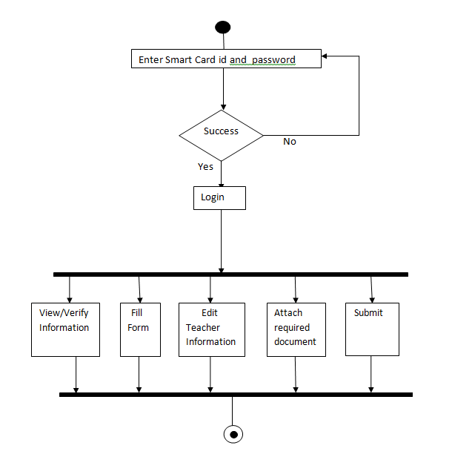

**Activity Diagram for Dean**

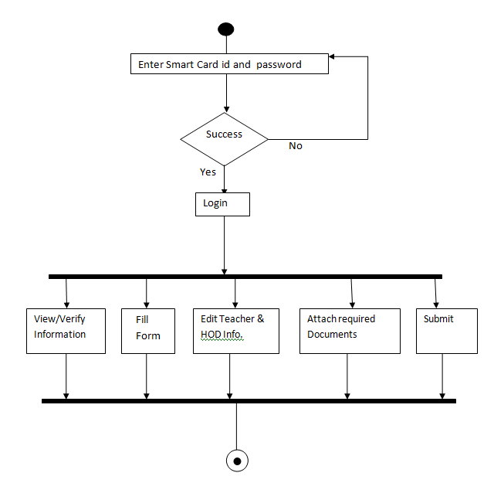

**Activity Diagram for Leave Management Coordinator**

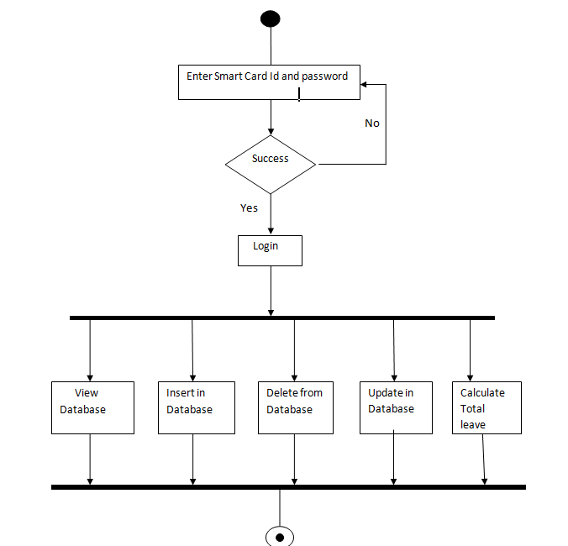

**Activity Diagram for Time-Table Management**

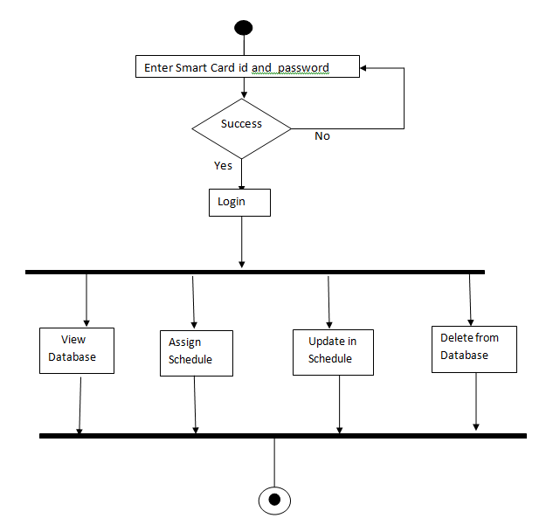

**Activity Diagram for Examination Duties**

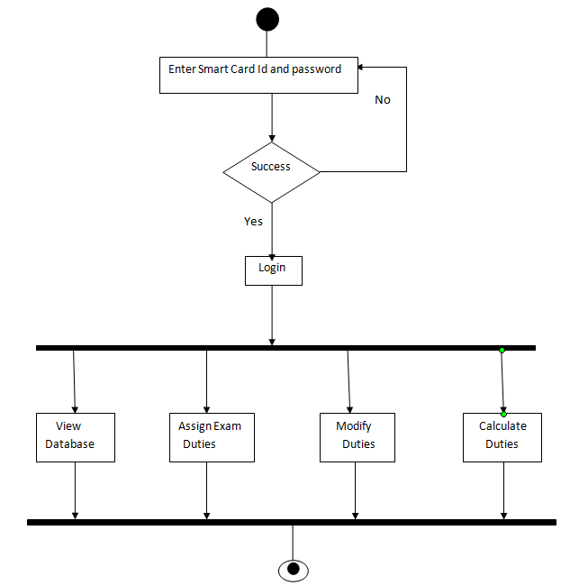

**Activity Diagram for Office Coordinator**

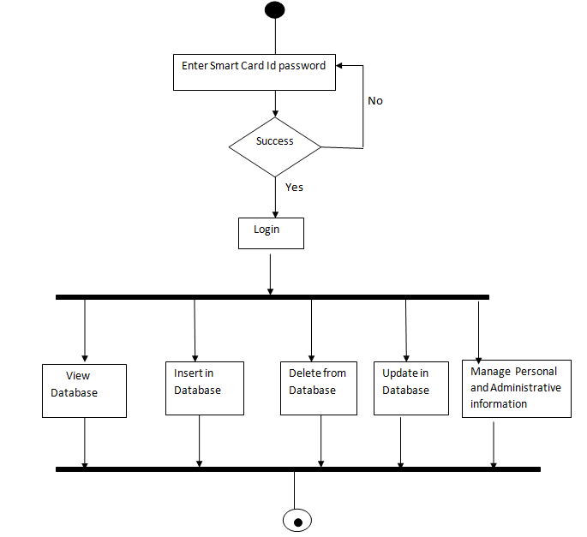

**2.2 SEQUENCE DIAGRAM**

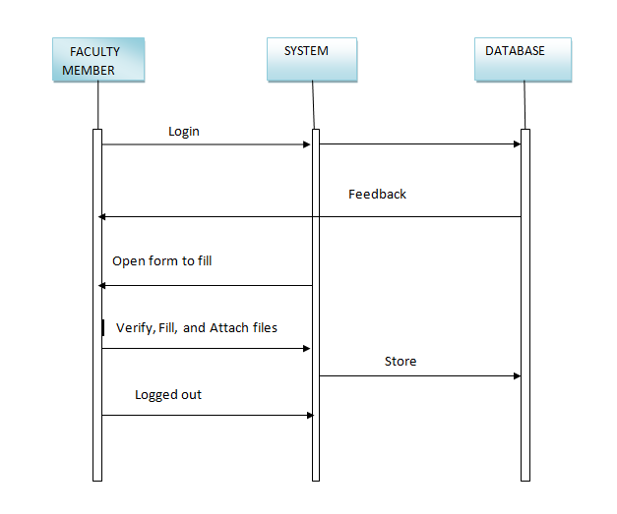

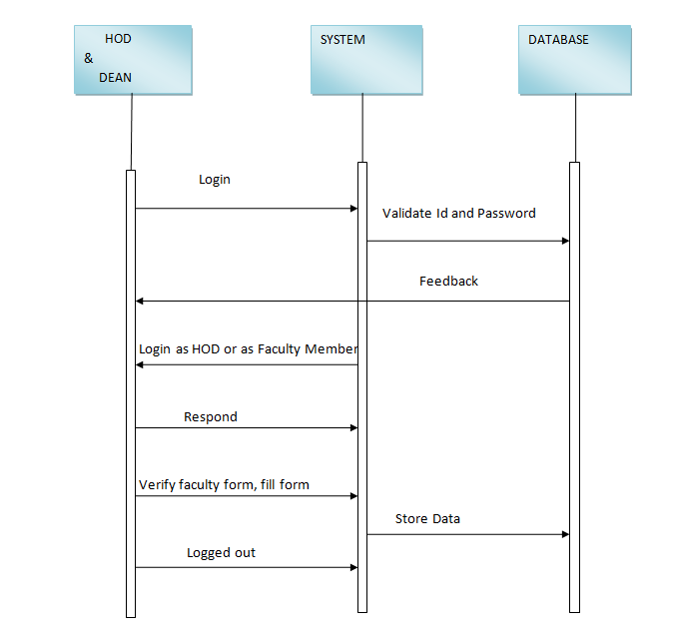

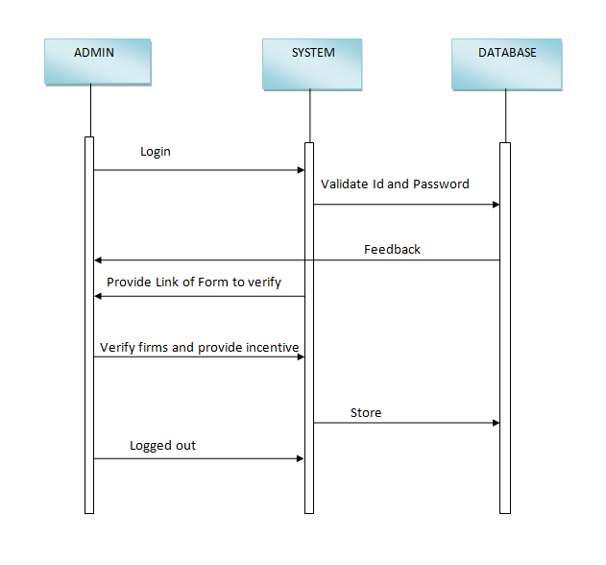

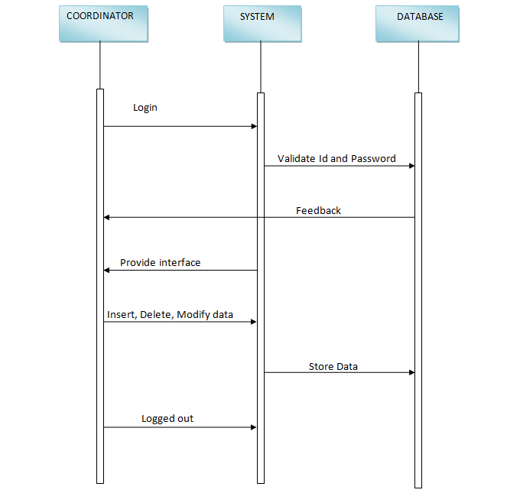

## 2.3 CLASS DIAGRAM

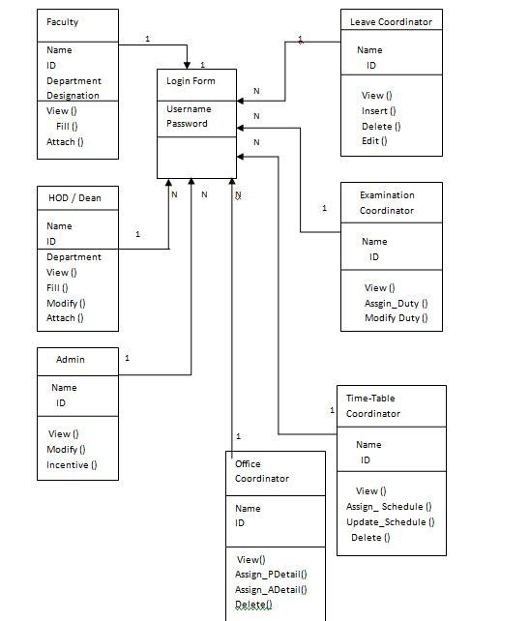

**2.4 ENTITY RELATIONSHIP DIAGRAM**

<ER.docx>

**3. DATA DESIGN**

**3.1 Structure & Relationships**

There are many different tables in this system:

**TABLE 1: Faculty and Higher Authority Table**

Purpose: This table is used for storing the login id and password.

|  |  |  |  |
| --- | --- | --- | --- |
| Fields | Type | Key | Null |
| Login_ID | Varchar2(20) | Primary Key | Not Null |
| Password | Varchar2(20) |  | Not Null |

**TABLE 2: Department Table**

Purpose: This table is used for storing the department name and its corresponding id.

|  |  |  |  |
| --- | --- | --- | --- |
| Fields | Type | Key | Null |
| Department_ID | Varchar2(20) | Primary Key | Not Null |
| Department_Name | Varchar2(20) |  |  |

**TABLE 3: Form Table**

Purpose: This table is used to store t Form details.

|  |  |  |  |
| --- | --- | --- | --- |
| Field | Type | Key | Null |
| Form_ID | Number | Primary Key | Not Null |
| Id | Varchar2(20) | Foreign Key |  |
| Date_of_sub | Date |  |  |

**TABLE 4: Personal Detail Table**

Purpose: This table is used for storing the personal details of Teachers, Higher Authority and Coordinators.

|  |  |  |  |
| --- | --- | --- | --- |
| Fields | Type | Key | Null |
| Name | Varchar2(20) |  | Yes |
| Designation | Varchar2(20) |  | Yes |
| Department_ID | Varchar2(20) | Foreign Key | Yes |
| Form_Id | Number | Foreign Key | Yes |

**TABLE 5: Institution Table**

Purpose: This table is used for storing the Institutional Responsibilities .

|  |  |  |  |
| --- | --- | --- | --- |
| Fields | Type | Key | Null |
| Responsibility | Varchar2(20) |  |  |
| Quality | Varchar2(20) |  |  |
| Credit Points | Number |  |  |
| Form_Id | Number | Foreign Key |  |

**TABLE 6: Departmental Res. Table**

Purpose: This table is used for storing Departmental Details.

|  |  |  |  |
| --- | --- | --- | --- |
| Fields | Type | Key | Null |
| Details | Varchar2(40) |  |  |
| Credit Points | Number |  |  |
| Form_Id | Number | Foreign Key |  |

**TABLE 7: Continuous_Assessment Table**

Purpose: This table is used for storing the continuous assessment details of students.

|  |  |  |  |
| --- | --- | --- | --- |
| Fields | Type | Key | Null |
| Form_Id | Number | Foreign Key |  |
| Class/Semester | Varchar2(20) |  |  |
| Course/Paper | Varchar2(20) |  |  |
| No_Student | Number |  |  |
| Cont_Ass Policy | Varchar2(20); |  |  |

**TABLE 8: Invigilation Table**

Purpose: This table is used for storing the data about examination duties of every teacher.

|  |  |  |  |
| --- | --- | --- | --- |
| Fields | Type | Key | Null |
| Form_Id | Number | Foreign Key |  |
| Credit Points | Number |  |  |
| Invigi_Duties | Number |  |  |
| Duties Attend | Number |  |  |
| Unauthorize_Ab | Number |  |  |
| Quality_Invigi | Varchar2(20) |  |  |

**TABLE 9: Academic Responsibilities**

Purpose: This table is used for storing all the academic details .

|  |  |  |  |
| --- | --- | --- | --- |
| Fields | Type | Key | Null |
| Form_Id | Number | Foreign Key |  |
| Academic_Commity | Varchar2(20) |  |  |
| Meeting_Attend | Varchar2(20) |  |  |
| Role & Responsibilities | Varchar2(20) |  |  |
| Quality Participation | Varchar2(20) |  |  |
| Credit Points | Number |  |  |

**TABLE 10: Examination_Coordinator Table**

Purpose: : This table is used to store the Examination details.

|  |  |  |  |
| --- | --- | --- | --- |
| Fields | Type | Key | Null |
| Ex_id | Varchar2(20) | Primary Key | Not Null |
| ID | Varchar2(20) | Forign Key |  |
| date | date |  |  |

**TABLE 11:Office_Coordinator Table**

Purpose: This table is used to store the Office details.

|  |  |  |  |
| --- | --- | --- | --- |
| Fields | Type | Key | Null |
| Office_ID | Varchar2(20) | Primary Key | Not Null |
| Id | Varchar2(20) | Foreign Key |  |
| Name | Varchar2(20) |  |  |
| Salary | Number |  |  |
| Designation | Varchar2(20) |  |  |

**TABLE 12: Admin Table**

Purpose: This table is used to store the Admin’s details.

|  |  |  |  |
| --- | --- | --- | --- |
| Fields | Type | Key | Null |
| ID | Varchar2(20) | Primary Key | Not Null |
| Name | Varchar2(20) |  |  |

**TABLE 13: Time-Table Coordinator**

Purpose: This table is used to store time-table details.

|  |  |  |  |
| --- | --- | --- | --- |
| ` Fields | Type | Key | Null |
| Tt_id | Varchar2(20) | Primary Key | Not Null |
| Year | Number |  |  |
| Id | Varchar2(20) | Foreign Key |  |

**Table 14: Leave Coordinator**

Purpose: This table is used to store the leave details.

|  |  |  |  |
| --- | --- | --- | --- |
| Fields | Type | Key | Null |
| L_type_id | Varchar2(20) | Primary Key | Not Null |
| Id | Varchar2(20) | Foreign Key |  |
| No_of_leaves | Number |  |  |
| Date_From | Date |  |  |
| Date_till | Date |  |  |

**4. USER INTERFACE DESIGN**

**4.1 SCREEN SHOTS**

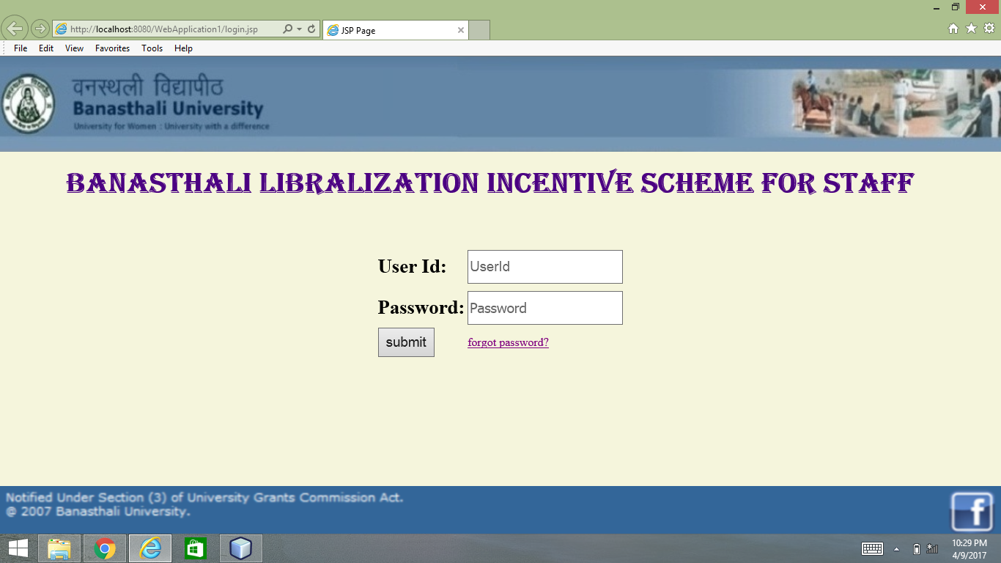

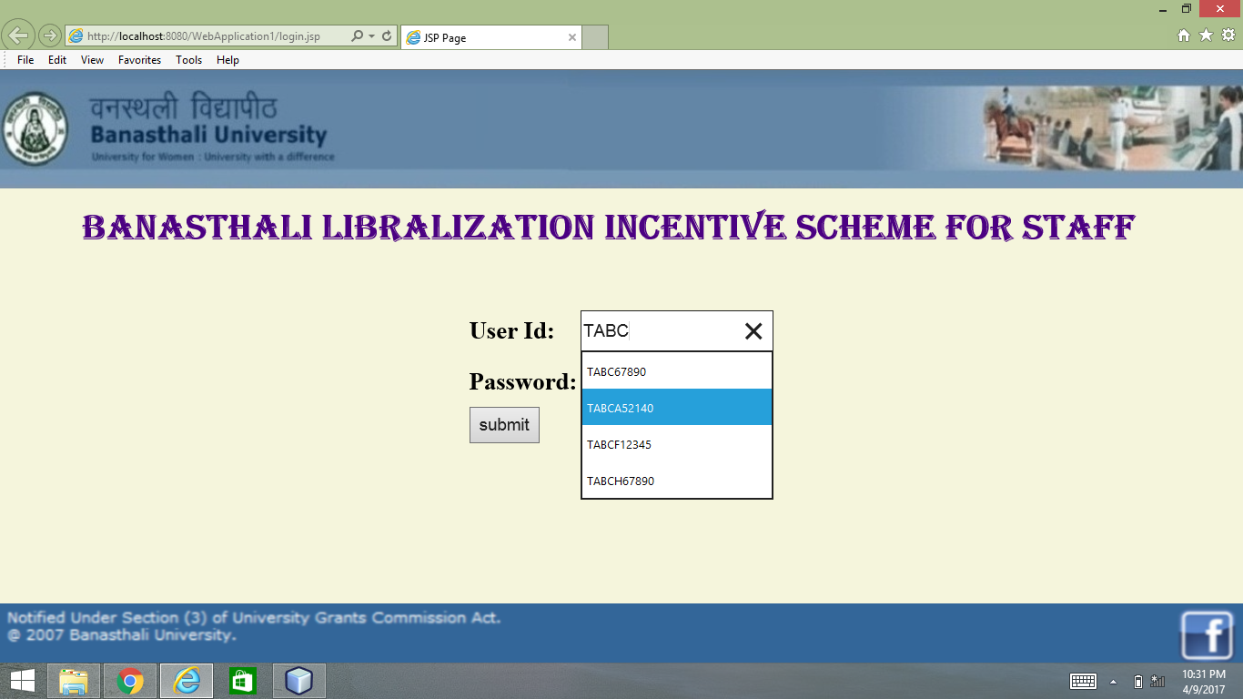

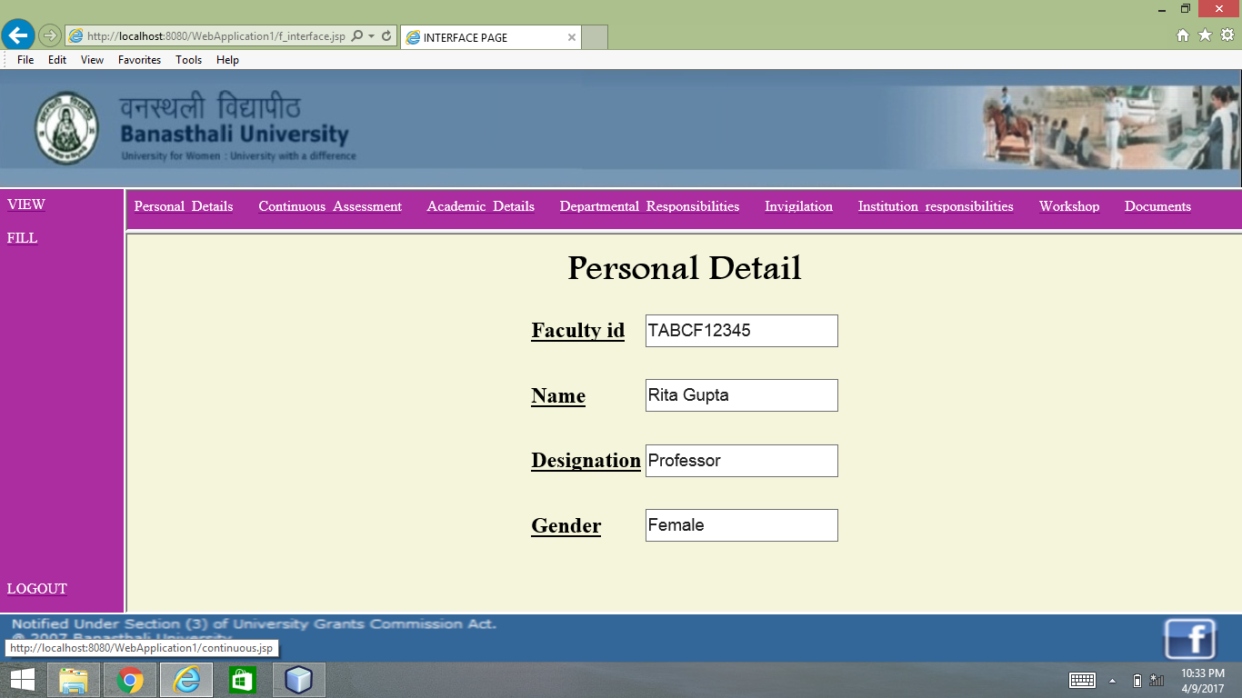

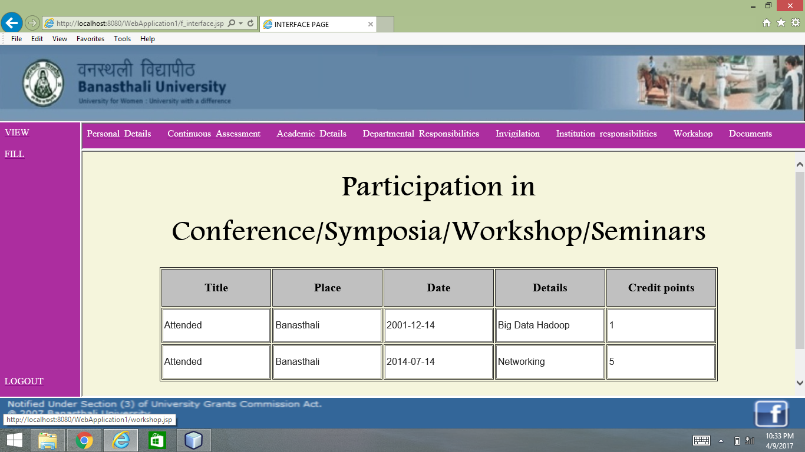

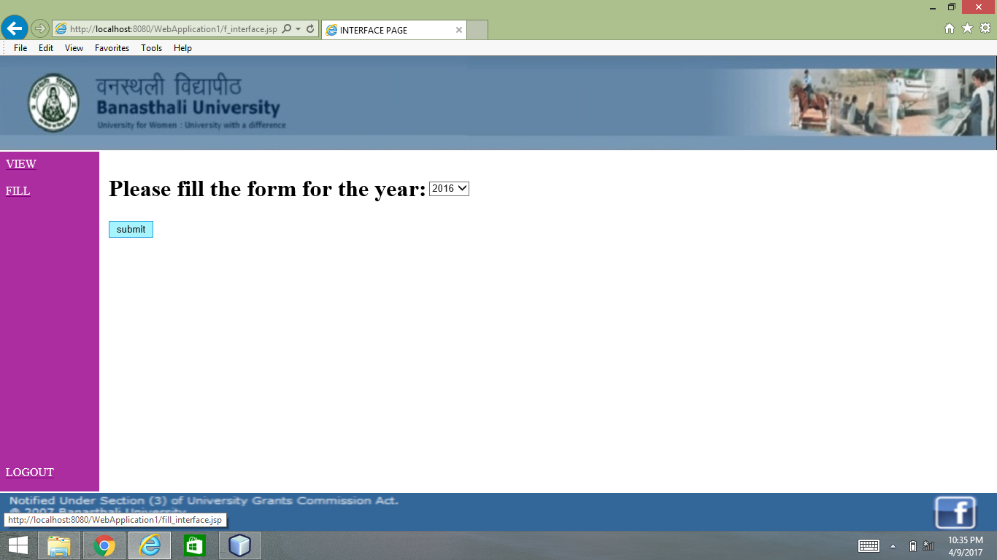

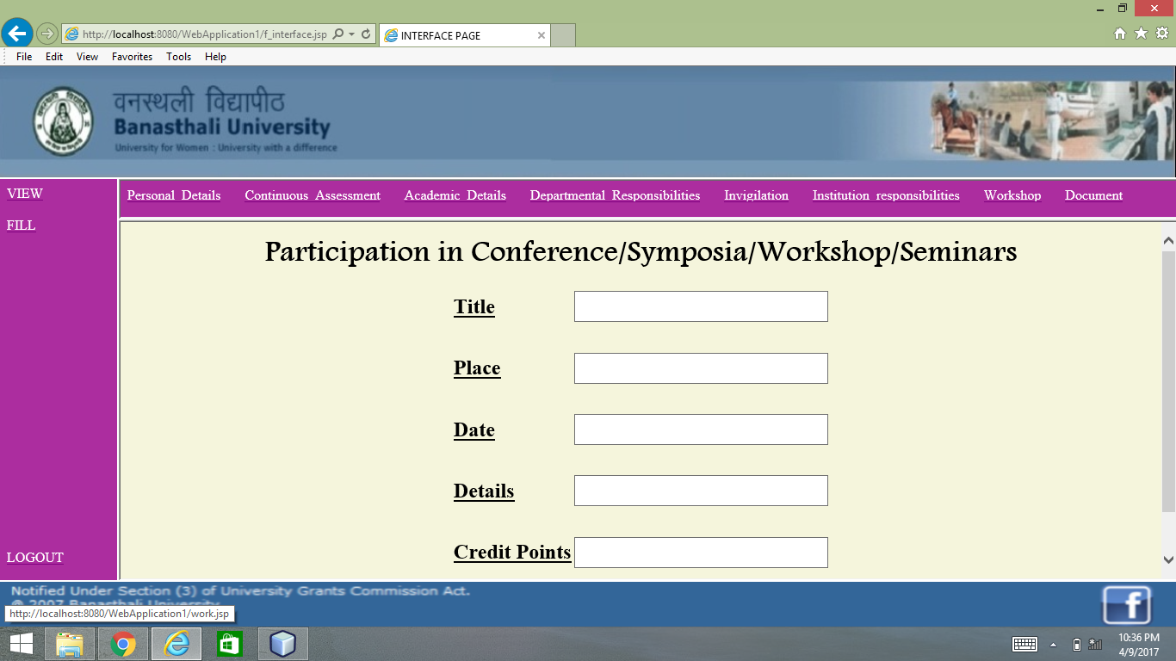

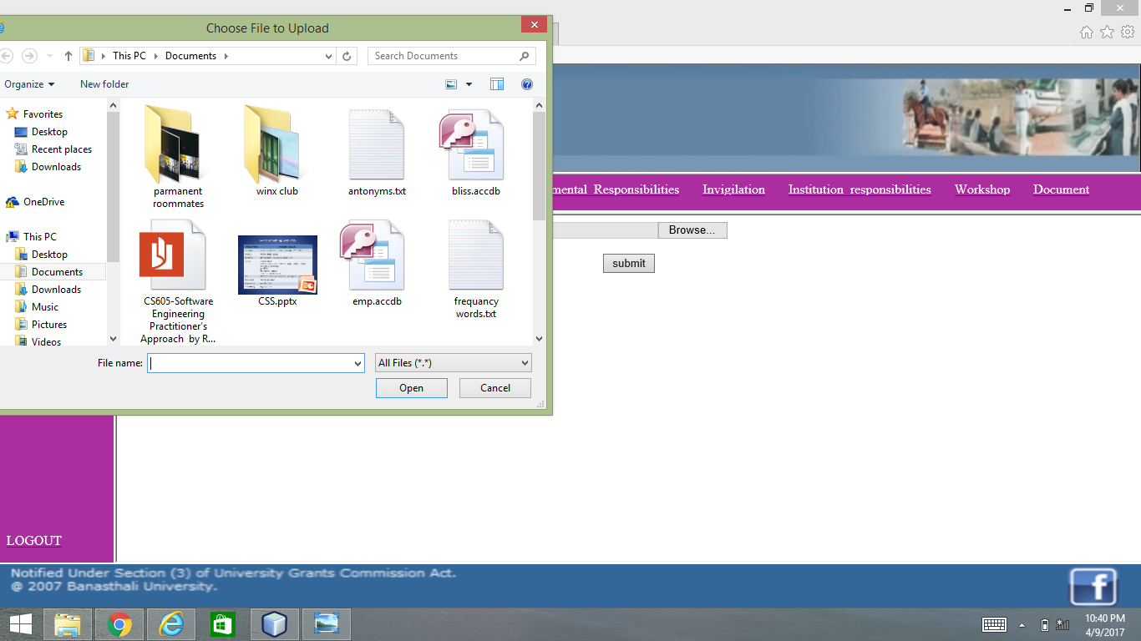

**5. CONCLUSION**

1. Our Project BLISS will automate the incentive procedure of Banasthali Vidyapith. It is a web –based service which intends to provide facility to Banasthali Vidyapith faculties to submit their appraisal form online.
2. This system facilitate the employees to fill the form online in which they don’t need to memorize things, they can easily fetch information from databases and also attach required documents.

**TESTING**

Testing is a process of executing a program with the intent of finding of an error. A good

Test case is one that uncovers as yet undiscovered error.

As a secondary benefit, testing demonstrates that software functions appear to be working

according to specification and those performance requirements appear to be met. In addition ,

data collected as testing is conducted which provides a good indication of the software

Reliability and some indication of software quality as a whole.

Unit Testing:

Unit testing concentrates on each unit of the software as implemented in the code. This is done due to check syntax and logical errors in programs. At this stage, the test focuses on each module individually, assuring that it functions properly as a unit. In our code, we have tested each of the modules.

Integration Testing:

The objective of the integration testing is to take unit tested components and build a program structure.

“The integration testing is a systematic technique for constructing the s/w architecture while at the same time conducting test to uncover errors associated with interfacing.”

System Testing:

System testing integrates the testing of s/w along with all the system elements, the various testing elements are hardware, people, database etc. System testing verifies that all the system elements are mesh properly and overall system’s function and performance is achieved.

**TEST CASES:**

Login:

|  |  |  |  |  |  |  |  |  |
| --- | --- | --- | --- | --- | --- | --- | --- | --- |
| **SNO.** | **TYPE** | **ID** | **PASSWORD** | | **EXPECTED OUTPUT** | **ACTUAL OUTPUT** | **PASS/FAIL** | |
| 1. | Login | TABCF12345 | 12345 | | Successfully logged in. | Successfully logged in. | Pass | |
| 2. | Login | TABCF58670 | 58670 | | Successfully logged in. | Successfully logged in. | Pass | |
| 3. | Login | TABCA52140 | 52140 | | Successfully logged in. | Successfully logged in. | Pass | |
| 4. | Login | TABCH67890 | 67890 | | Successfully logged in. | Successfully logged in. | Pass | |
| 5. | Login | TABCD21750 | 21750 | | Successfully logged in. | Successfully logged in. | Pass | |
| 6. | Login | TABCE19976 | 19976 | | Successfully logged in. | Successfully logged in. | Pass | |
| 7. | Login | TABCL12367 | 12367 | | Successfully logged in. | Successfully logged in. | Pass | |
| 8. | Login | TABCT15446 | 15446 | | Successfully logged in. | Successfully logged in. | Pass | | |
| 9. | Login | TABCO123456 | 123456 | | Successfully logged in. | Successfully logged in. | Pass | | |
| 10. | Login | TABCF1235 | 12345 | | Invalid Id or Password. | Not logged in. | Fail | | |
| 11. | Login | TABCE19975 | 19976 | | Invalid Id or Password. | Not logged in. | Fail | | |
| 12. | Login | TABCH67890 | 67899 | | Invalid Id or Password. | Not logged in. | | Fail | |
| 13. | Login | TABCT15445 | | 15446 | Invalid Id or Password. | Not logged in. | | Fail | |
| 14. | Login | TABCL12367 | | 13367 | Invalid Id or Password. | Not logged in. | | Fail | |

Forget Password:

|  |  |  |  |  |  |  |  |
| --- | --- | --- | --- | --- | --- | --- | --- |
| **SNO.** | **ID** | **PASSWORD** | | **EXPECTED OUTPUT** | | **ACTUAL OUTPUT** | **PASS/FAIL** |
| 1. | TABCF12345 | 12345 | | Successfully logged In. | | Successfully logged In. | Pass |
| 2. | TABCD21750 | 21750 | | Successfully logged in. | | Successfully logged in. | Pass |
| 3. | TABCH67890 | 67890 | | Successfully logged In. | | Successfully logged In. | Pass |
| 4. | TABCH67890 | | 67855 | Invalid Id or Password | Not logged In. | | Fail |
| 5. | TABCF12346 | | 12345 | Invalid Id or Password | Not logged In. | | Fail |
| 6. | TABCD21750 | | 22170 | Invalid Id or Password | Not logged In. | | Fail |

**APPENDICES**

PERFORMANCE ISSUES:

* The performance depends upon the load on the server, system configuration.
* The application can support multiple numbers of users at a time.

PACKAGING AND INSTALLING ISSUES:

* Uploading the software in order to make this application online.
* The URL will provide the access to the site. The client needs to have an internet connection and web browser.

SUPPLEMENTARY INFORMATION:

* The project being developed is at student level. For the purpose of implementation some more functionality may be considered.

**REFERENCES**

1. IEEE Standard 830-1993, IEEE Recommended Practice for Software Requirements Specifications.

2. Jalote, Pankaj, An Integrated Approach to software Engineering (Third Edition)

3. IEEE STD 830-1998, IEEE Recommended Practice for Software Design Specifications.

4. Pressman, Roger S., Software Engineering Practitioner’s Approach, Sixth Edition, Tata McGraw-Hill Edition 2010

6. Awad, Elias M., System Analysis and Design, Galgotia Publications (P) Ltd. 2007